Name: Juliette Joseph-Odogbo
Class: Linux Administration
Date: 10/3/2025
Assignment: SedLab.txt
- Change the name Jo to Josephine.

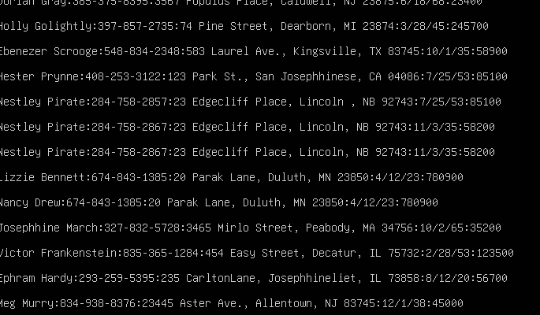
Command: sed 's/Jo/Josephine/g' SedLab.txt
How this command works:
- sed → reads the file line by line and applies the instruction inside the pattern
- s/Jo/Josephine/ → tells sed to substitute the first occurrence of Jo with Josephine on each line:
  - s// means substitute .
  - Jo is the pattern to look for.
  - Josephine is the replacement text.
- The g at the end means “global,” so it replaces all occurrences in each line in the file

Why:
We used this command to update every appearance of Jo to Josephine throughout the file without manually editing each line.

- Delete the last 5 lines.

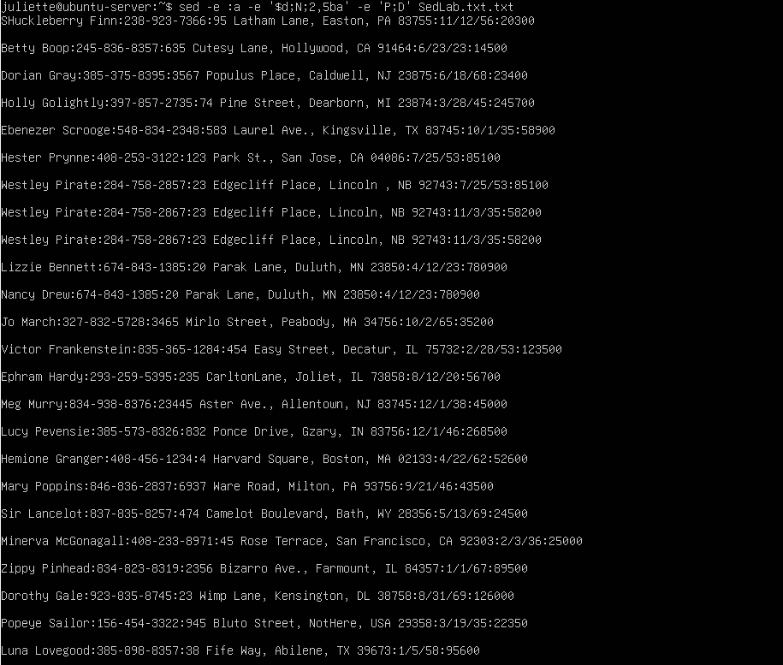
Command: sed -e :a -e '$d;N;2,5ba' -e 'P;D' SedLab.txt.txt
How:
In my understanding, this command tells sed to start from the bottom of the file and delete lines going upward, one by one, until it removes five lines.
The -e option allows me to give sed multiple instructions in one command. Instead of writing one long complicated instruction, I can break it into smaller steps using multiple -es.
The first part, :a, sets a starting point, like the top of a loop.
The $d part is the first deletion — it deletes the very last line in the file (the $ means “end of file” and d means delete).
Then N tells sed to grab the next line from the file so that the loop can keep going. Without N, sed would delete one line and stop, but with N, it keeps pulling in the next line to continue the process.
The 2,5ba part is where the looping happens. It tells sed: starting from the second time, and continuing through the fifth time, go back to the label a and repeat the deletion. So sed deletes one line the first time, then loops back on the 2nd, 3rd, 4th, and 5th times to delete more lines from the bottom. By the time the fifth loop finishes, sed has deleted exactly five lines, working from the bottom upward.
Finally, the P;D part makes sed print the rest of the file line by line so the output looks clean after the last 5 lines have been deleted.

Why:
This works because the $d command handles the first deletion, and then the 2,5ba makes sed loop back to delete the next four lines. In total, that gives us five deletions from the bottom of the file. The N command is what allows sed to keep pulling in the next line during each loop so it does not stop after the first deletion. The P; D at the end makes sure the remaining lines are printed correctly.
So instead of deleting all five lines at once, sed deletes them one at a time in a loop until five lines are gone, which is exactly what the question asked.

- Print lines 3-15.
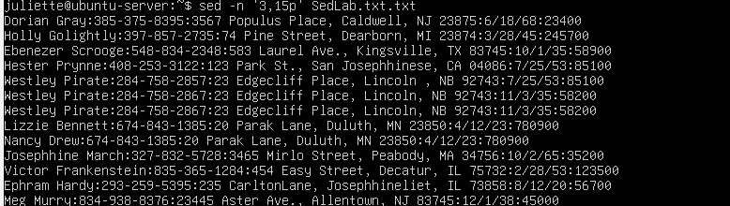
Command: sed -n '3,15p' SedLab.txt.txt
How this command works:
In my understanding, this command uses sed to only print the lines between line 3 and line 15, and ignore the rest.
The -n option tells sed not to print anything automatically. By default, sed prints every line, but with -n, it will only print the lines I tell it to.
The '3,15p' part is the main instruction. The 3,15 sets the range of lines — starting at line 3 and ending at line 15. The p means “print.” So sed looks through the file line by line and prints only lines 3 through 15, nothing else.
Why:
This works because the -n option stops sed from printing the whole file, and '3,15p' focuses on the exact range I want. By giving it a start line (3) and an end line (15), sed prints only that section and ignores everything else. This is the simplest way to extract a specific block of lines from a file.

- Delete lines for people who live in California.
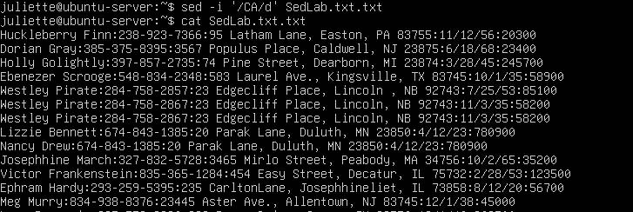
Command: sed '/CA/d' SedLab.txt.txt.
How this command works:
In my understanding, this command makes sed go through the file line by line and remove any line that has “CA” in it.
The ‘/CA/’ part is the pattern. Sed checks each line to see if “CA” appears anywhere — in this case, it is usually in the address field where the state is written. If the line has “CA,” sed matches it.
The d at the end tells sed to delete any line that matches CA. That means all the lines for people who live in California will be removed from the output, while the other lines stay.
Why:
This works because sed looks for the pattern /CA/ in every line. If it finds “CA,” it deletes that line and moves to the next one. This way, all the lines with “CA” in them are removed, and the other lines remain. It is a clear and easy way to remove the California lines without having to know exactly where they are in the file.

- Print all lines where the birthdays are in the first week of the month. Be careful of the dates for birthdays, the format is MM/DD/Y.
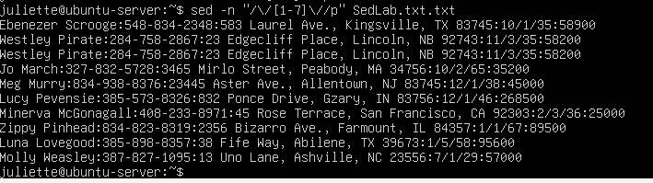
Command: sed -n '/\/[1-7]\//p' SedLab.txt.txt
How:
In my understanding, this command tells sed to go through the file and print only the lines where the birthday day is between 1 and 7, meaning people born in the first week of the month.
- The -n part tells sed:
  - “Do not print the whole file like you normally do. Stay quiet unless I tell you to print.”
Without -n, sed would show every line in the file along with the matches.
- The pattern in the middle, /\/[1-7]\//, is how sed finds birthdays in the first week:
  - The first slash tells sed, “Here is where my pattern starts.”
  - The next part \/ matches the slash after the month in the date (for example, in 10/2/65 it is the slash after 10).
  - The [1-7] matches the day of the birthday, but only if it is 1, 2, 3, 4, 5, 6, or 7.
  - The next \/ matches the slash right after the day (in 10/2/65, this is the slash after the 2).
  - The last slash closes the pattern.
- The p at the end means prints. Because we used -n, sed will now only print the lines that fit this pattern.
So together, the command finds dates like 10/2/65, 7/1/29, 12/1/46, etc., and prints those lines. Lines with birthdays like 6/18/68 or 4/22/62 will not show up because the day is greater than 7.

Why:
This works because the dates in the file are written in the format month/day/year. The command looks for the slash after the month, checks if the number after it is between 1 and 7, and then makes sure there is another slash after the number. This guarantees that the number we are matching is the day of the birthday.
The -n is important because it stops sed from printing everything, and the p makes sure sed only prints the lines that meet the rule. That way, the output shows exactly the birthdays in the first week of the month and nothing else.
6. Append three asterisks (*) to the end of lines starting with Sir
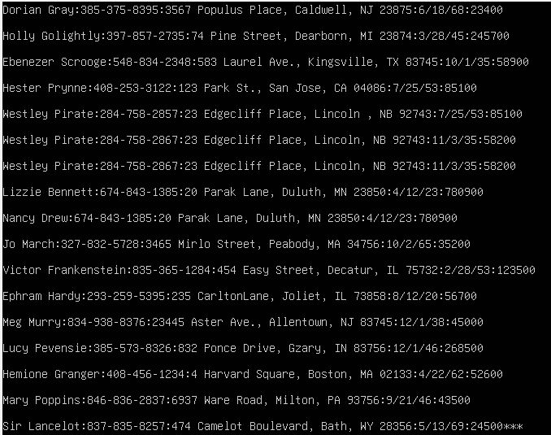
Command: sed '/^Sir/s/$/***/' SedLab.txt.txt
How:
In my understanding, this command tells sed to look for every line that starts with the word “Sir” and then add three stars (***) to the very end of those lines.
- The /^Sir/ part means: look for lines that begin with Sir. The ^ is a symbol that means “at the start of the line.” So only lines that start with “Sir” are chosen.
- The s stands for “substitute.” This tells sed to replace part of the line with something else.
- The $ inside the s command means “the end of the line.”
- The ***/ is what we are adding — three asterisks at the end of the line.

Why this command works
- This works because sed checks the beginning of each line for the word “Sir.” When it finds such a line, the $ tells sed to go to the end of that line, and then *** is added there. This way, only the lines that start with “Sir” get changed, and the rest of the file stays the same.
.
7. Replace the line containing” Westley Pirate” with the phrase” As you wish.” Make sure you replace the whole line not just the name.
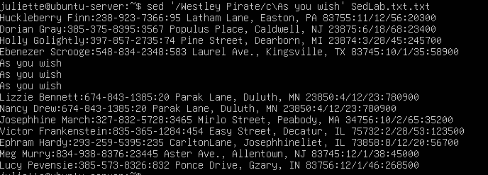.
Command: sed '/Westley Pirate/c\As you wish.' SedLab.txt.txt
How this command works:
In my understanding, this command tells sed to search for any line that has the words “Westley Pirate” in it and then completely change that whole line into the sentence “As you wish.”
- The /Westley Pirate/ part means: find any line that contains the text “Westley Pirate.”
- The c\ means “change this entire line.”
- After c\, we type exactly what we want that line to become — in this case, the words “As you wish”.
So instead of just replacing the name, sed replaces the whole line.
Why:
This works because the c\ command in sed is designed to replace the full line that matches the pattern, not just a small part of it. By using /Westley Pirate/, sed finds every line with that name, and c\As you wish. makes the entire line turn into “As you wish.” This makes sure we follow the question’s instruction to replace the whole line, not just the name.

- Change Minerva McGonagall’s birthday to 10/04/1935. Assume you do not know Minerva’s original birthday. Use a regular expression to search for it.
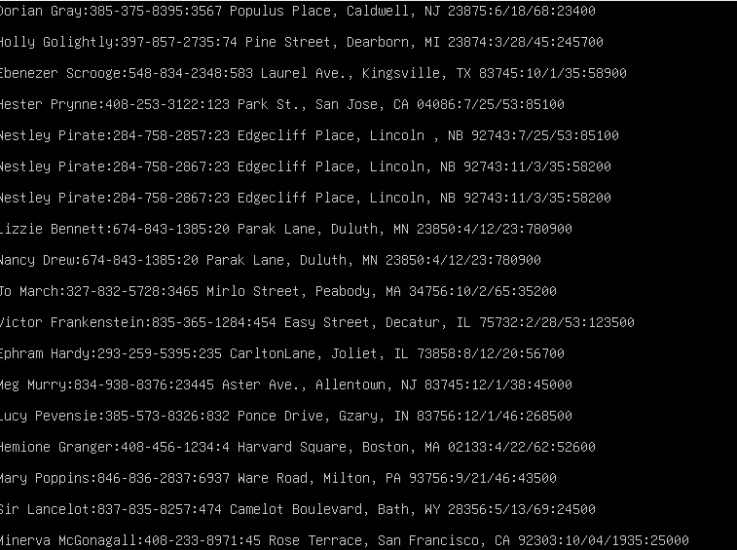
Command: sed “/Minerva McGonagall/s/[0-9]\{1,2\}\/[0-9]\{1,2\}\/[0-9]\{2,4\}/10\/04\/1935/” SedLab.txt.txt
How This Command Works
- sed → This is the tool I am using to edit text. It can search through a file and change specific parts without opening it in an editor.
- "/Minerva McGonagall/" → This tells sed to look for the line that has Minerva’s name. The rest of the command will only happen on that line.
- s/s / what_to_find / what_to_put_instead // → The s means “substitute.”
  - It follows the idea: find this pattern and replace it with this new text.
  - Right after s/, I write the pattern that matches the date I want to change. After the next /, I put the new date.
- [0-9]\{1,2\} (first number) →
  - [0-9] means any single number from 0 to 9.
  - \{1,2\} means there can be one or two numbers.
  - Together, this matches the month part of the date (like 7 or 12).
- \/ (first slash) →
  - This is the first slash in the date.
  - It separates the month from the day, like the / in 12/25/1935.
- [0-9]\{1,2\} (second number) →
  - This part works the same way as the first number, but now it matches the day.
  - It covers days with one or two digits, like 3 or 25.
- \/ (second slash) →
  - This is the second slash.
  - It separates the day from the year, like the second / in 12/25/1935.
- [0-9]\{2,4\} (third number) →
  - This matches the year.
  - It can be two digits (like 35) or four digits (like 1935).
- 10\/04\/1935 (replacement) →
  - This is the new date I want to put in.
  - The slashes are escaped so they stay in the result.
- SedLab.txt.txt →
  - This is the file where the change happens.
  - Since I did not use the -i option, it does not overwrite the file — it just shows the updated line on the screen.

Why this command works:
This works because the pattern is built to cover every part of the date structure, even when I do not know the original birthday.
- The [0-9] and {1,2} make sure both one-digit and two-digit months/days are matched.
- The slashes show sed where each part of the date ends and the next part begins.
- The {2,4} makes sure the year is matched, whether it is written with 2 digits or 4 digits.
Since we first search for Minerva’s name, the change only happens in her line — no other birthdays are touched. The old date is fully replaced with the new one in the correct format.

- Delete all blank lines.
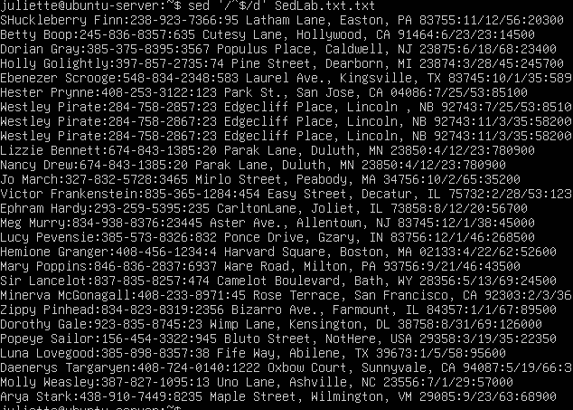
Command: sed '/^$/d' SedLab.txt.txt
How this command works
- sed is the stream editor that processes the file line by line.
- ^: matches the start of a line.
- $: matches the end of a line.
- Together ^$ matches a line that starts and ends immediately — meaning nothing is between them → a blank line.
- d: deletes any line that matches the ^$ pattern.
Why this works:
It works because the ^$ tells sed to look for lines that start and end with no characters in between, which are blank lines. The d command then deletes those blank lines from the output. The $ symbol is necessary — without it, ^ would just match the beginning of every line, not only the empty ones. With both ^ and $, sed can target only the blank lines and remove them.

- Write a sed script that will (actual sed script, NOT just the commands on the command line) (a) Insert above the first line the title- Great Literary Characters-. (b) Print the contents of the file, but instead of the phone number starting with an area code, have it start with a 1+, then include the area code and number. For example, (603)123-1234 would turn into 1+(603)123-1234 (c) Append at the end of the file” Happily Ever after. The End.
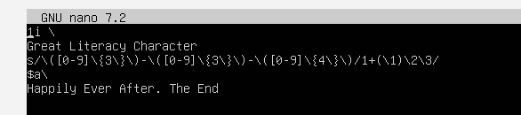

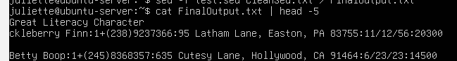
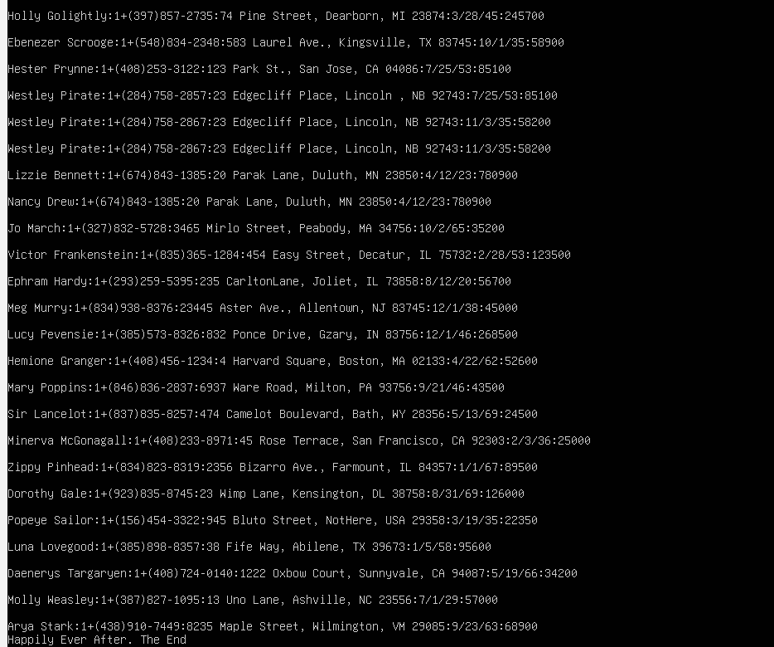

Command:
1i\
Great Literary Characters
s/\([0-9]\{3\}\)-\([0-9]\{3\}\)-\([0-9]\{4\}\)/1+(\1)\2-\3/
$a\
Happily Ever After. The End

How this command works:
1i\ — Insert at the Beginning
1i\
Great Character
- 1 → This means the first line in the file.
- i\ → This tells sed to insert a new line before that first line.
- Great Character → This is the actual text that will be inserted.
So, this part adds a new line at the very top of the file with the text:
Great Character
If the file originally started with “Huckleberry Finn,”
now the very first line will be “Great Character,” followed by the original content.
s/// — Substitution (Phone Number Reformatting)
s/\([0-9]\{3\}\)-\([0-9]\{3\}\)-\([0-9]\{4\}\)/1+(\1)\2-\3/
This line tells sed to find phone numbers in the format 123-456-7890 and reformat them into a new style like 1+(123)456-7890.
s
- The letter s tells sed to substitute something in the line.
- The format is always:
- s / pattern_to_find / replacement /
Search Pattern
\([0-9]\{3\}\)-\([0-9]\{3\}\)-\([0-9]\{4\}\)
We are looking for a phone number broken into 3 parts.
- \([0-9]\{3\}\)
  - [0-9] means any digit.
  - \{3\} means exactly three digits.
  - \(...\) groups this part for later use.
This matches the first 3 digits (the area code) — Group 1 (\1).
- -
  - Matches the first dash.
- \([0-9]\{3\}\)
  - Matches the next 3 digits (middle part of the phone number).
This is Group 2 (\2).
- -
  - Matches the second dash.
- \([0-9]\{4\}\)
  - Matches exactly 4 digits (the last part).
This is Group 3 (\3).
Example:
For 978-555-1234
- \1 = 978
- \2 = 555
- \3 = 1234

Replacement Pattern
1+(\1)\2-\3
This tells sed how to rebuild the number after finding it:
- 1+( → Adds 1+( at the beginning.
- \1 → Inserts the first group (area code).
- ) → Closes the parentheses.
- \2 → Inserts the middle 3 digits.
- - → Adds a dash.
- \3 → Inserts the last 4 digits.
So, 978-555-1234 becomes:
1+(978)555-1234

$a\ — Append at the End
$a\
Happily, Ever After. The End
- $ → Targets the last line of the file.
- a\ → Tells sed to append a new line after that last line.
- Happily Ever After. The End → This is the text to add.
This part simply adds a new line at the bottom of the file with:
Happily, Ever After. The End

Why this command works:
I used groups so I could grab each part of the phone number and then rebuild it in a new format. The [0-9]\{3\} and [0-9]\{4\} made sure I was matching the right digits (3 for the area code and middle, 4 for the end). By adding 1+( before the first group and ) after it, the area code shows up inside parentheses. Finally, I used $a\ so an extra line gets added at the bottom of the file with the sentence “Happily Ever After. The End.”

References:
GeeksforGeeks: https://www.geeksforgeeks.org/sed-command-in-linux-unix-with-examples/
TutorialsPoint: https://www.tutorialspoint.com/unix_commands/sed.htm
FreeCodeCamp: https://www.freecodecamp.org/news/the-linux-commands-handbook/
GNU sed Manual: https://www.gnu.org/software/sed/manual/

